**Default exp**: Comparing the performance of 256 MLP vs NCAP models, both trained with PPO, n_joint= 5, Viscosity= 0.

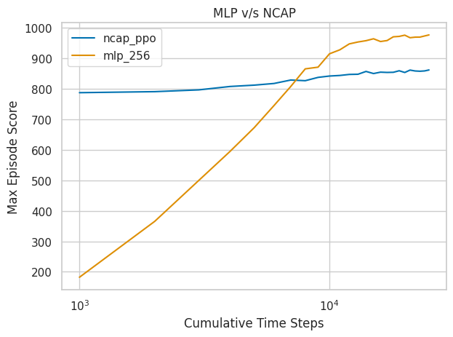

**Exp1:** Exploring the effect of (fix) viscosities on 256 MLP vs NCAP model’s performance. We compare an environment with zero viscosity vs the viscosity of air that is around 0.00002 and the viscosity of water which is around 0.0009.

